DINE-N-CA$H

WITH

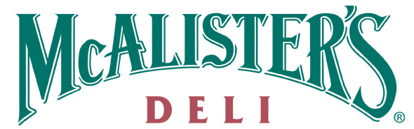
Supporting

Gift Of Love Christmas Store
On Tuesday-November 17, 2009 and Thursday-December 3, 2009 from 4pm until close, McAlister’s Deli will be donating 15% of all receipts returned with this flier from the Gift Of Love Christmas Store for its help in promoting our Dine-n-Ca$h program.

Your organization can copy as many fliers as you want to pass out to friends and family. The more people you bring in from 4pm-close the more money you can make! All you have to do is promote your event, pass out fliers and bring in everyone you know!

This offer is only valid on the night of your event and at this restaurant: 14848 Manchester Rd, in Ballwin.

15% donation includes all sales from 4pm-close and is less tax and any discounts. Flier must be presented at the time of purchase. Organizations will not be allowed to pass out fliers at the front door of the event itself.

